Fruit Ninja Report

Names :

1-Hussen Adel Mohamed ID:5783

2- Magdy Sedra ID:5052

3-David Helmy ID:5606

4- Yehia Ayad ID:5781

Class Diagram

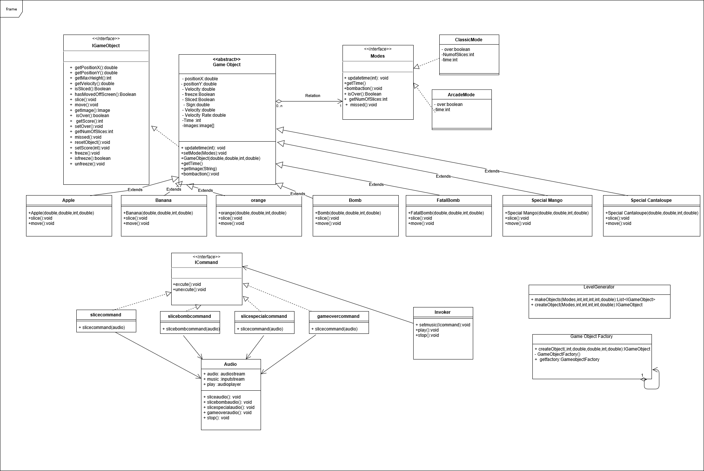

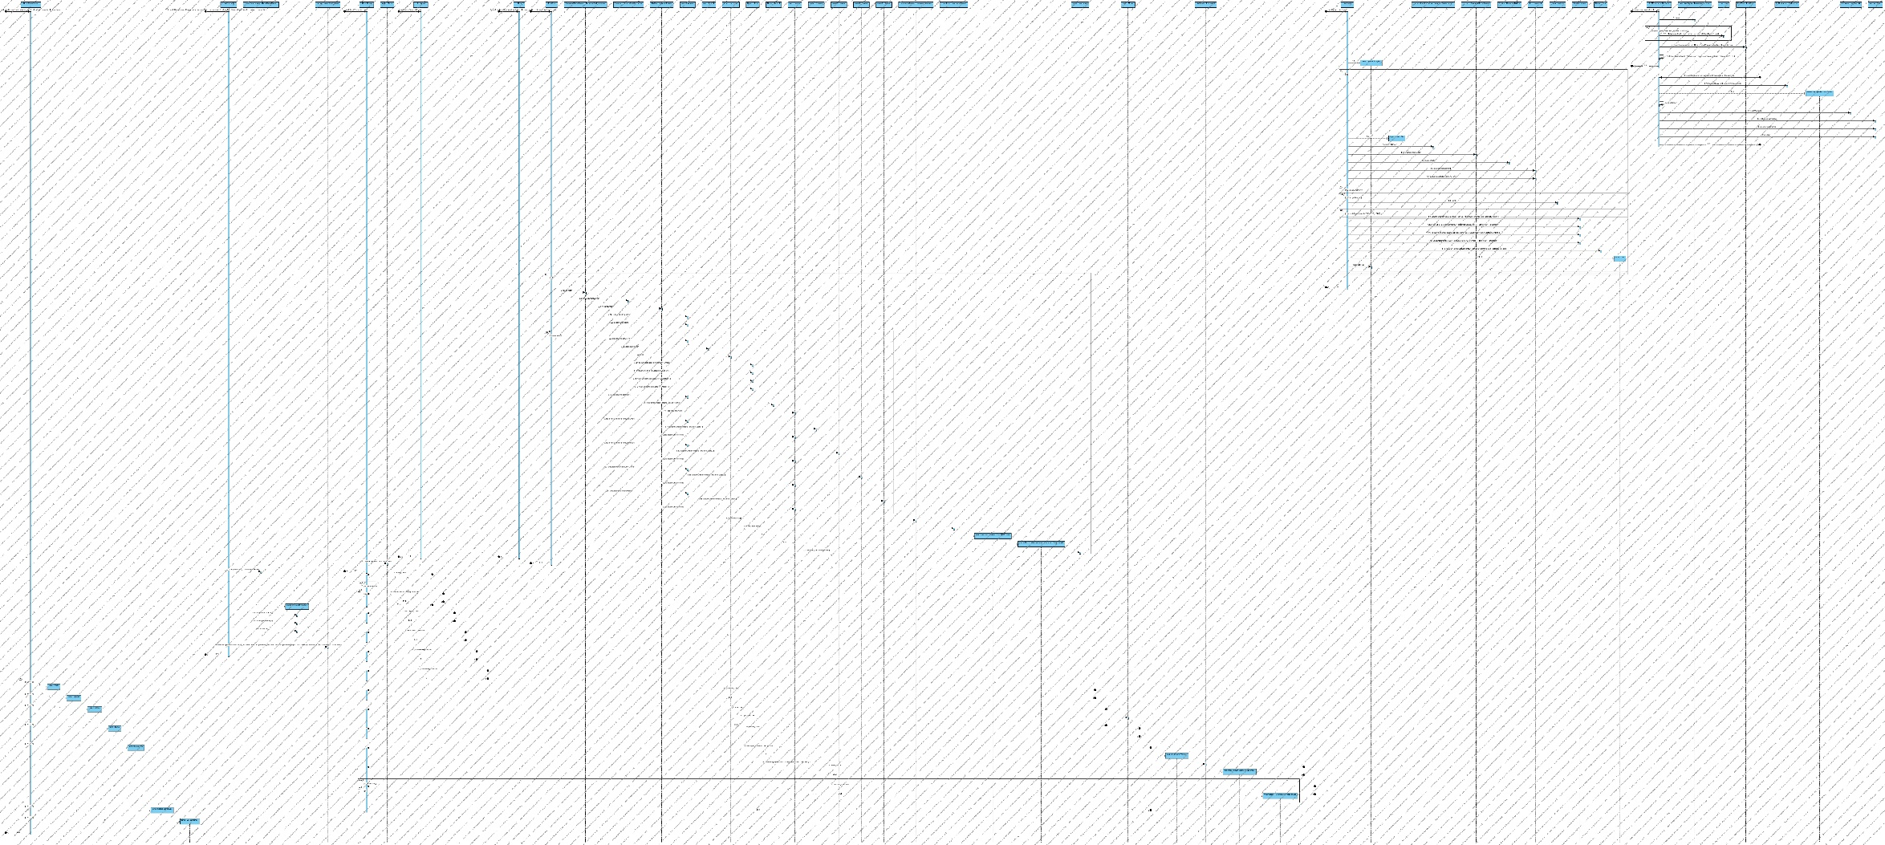Sequence Diagram

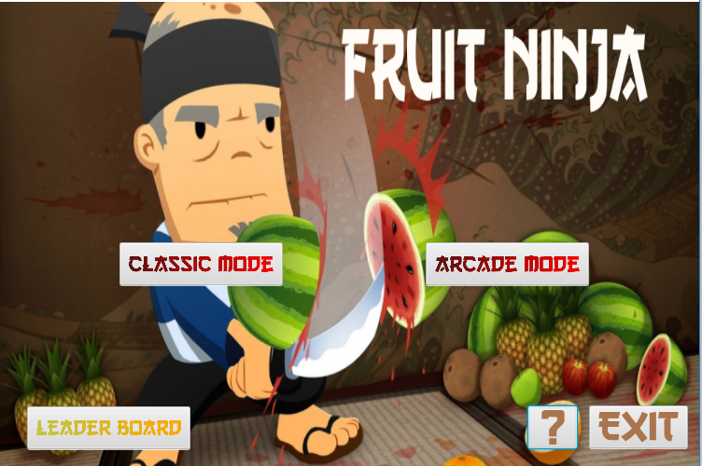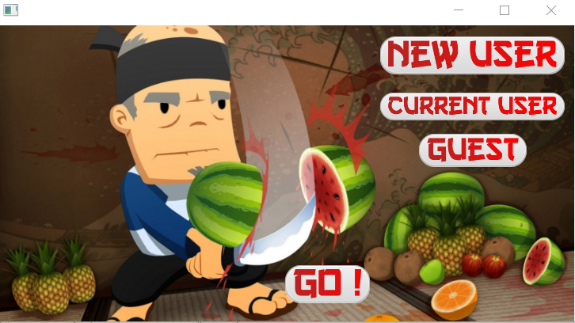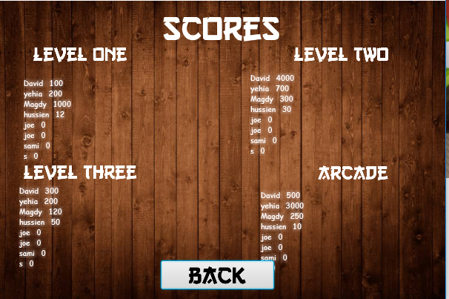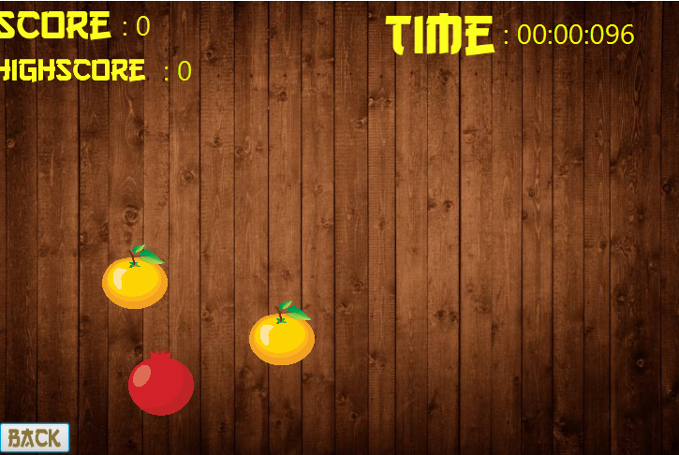Samples From Game

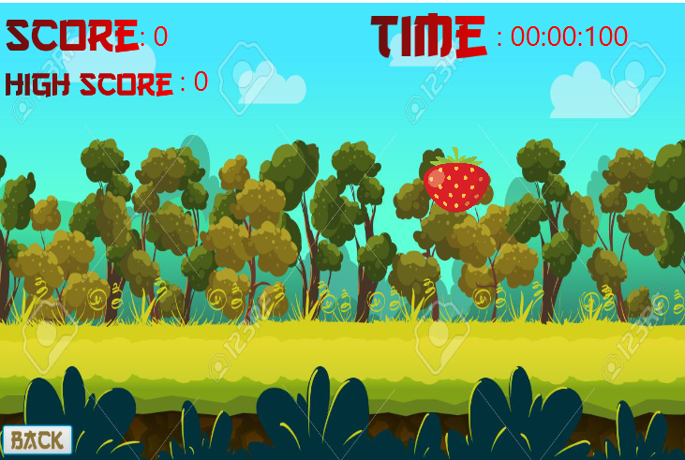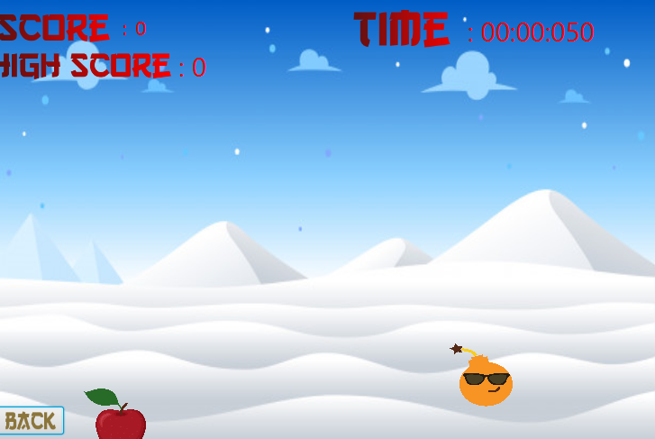c

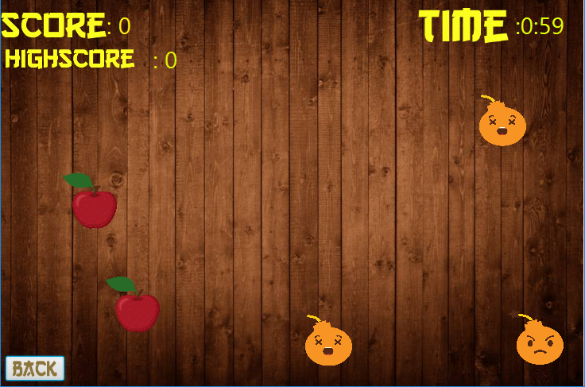

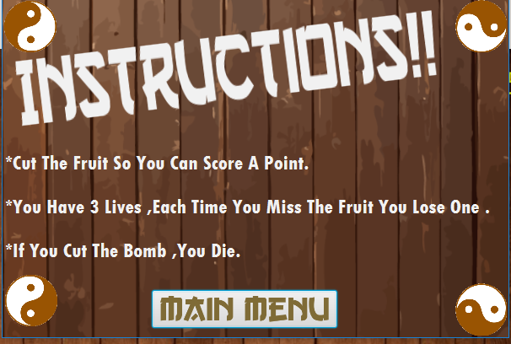

Game Description.

You first have a choice to play as a guest or as an existing user or to create an user.

Then you can choose which mode you want to play Classic Or Arcade.

If you play Classic you have an option of 3 levels with differents arenas and increasing difficulty.

If You play Arcade you have a specific time to play then you get your score.

And then you can check the leaderboard for both levels and game modes.

Design Pattern :

1. Factory: to create Objects
2. Singleton : in Factory
3. Strategy: In Game Modes
4. Command: In audios